**WORKING WITH CONSTRAINTS**

Find the Solution for the following:

1. Add a table-level PRIMARY KEY constraint to the EMP table on the ID column.The constraint should be named at creation. Name the constraint my_emp_id_pk.

ALTER TABLE EMP ADD CONSTRAINT my_emp_id_pk PRIMARY KEY (ID);

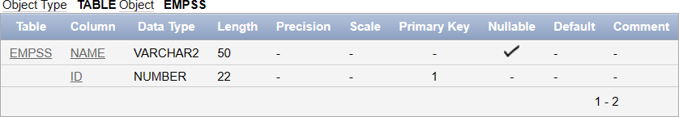

1. Create a PRIMAY KEY constraint to the DEPT table using the ID colum. The constraint should be named at creation. Name the constraint my_dept_id_pk.

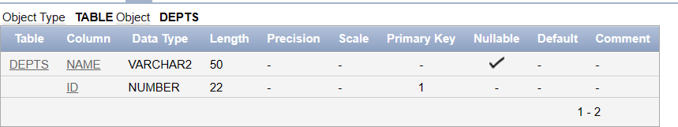ALTER TABLE DEPT ADD CONSTRAINT my_dept_id_pk PRIMARY KEY (ID);

1. Add a column DEPT_ID to the EMP table.

ALTER TABLE EMPSS ADD DEPT_ID NUMBER;

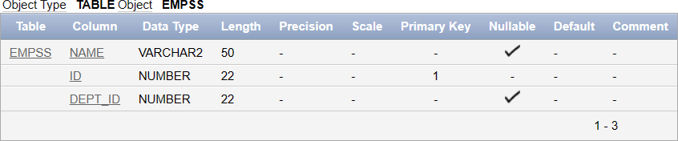

Add a foreign key reference on the EMP table that ensures that the employee is not assigned to nonexistent deparment. Name the constraint

my_emp_dept_id_fk.

ALTER TABLE EMPSS

ADD CONSTRAINT my_emp_dept_id_fk FOREIGN KEY (DEPT_ID)

REFERENCES DEPTS(ID);

1. Modify the EMP table. Add a COMMISSION column of NUMBER data type, precision

2, scale 2. Add a constraint to the commission column that ensures that a commission value is greater than zero.

ALTER TABLE EMP ADD COMMISSION NUMBER(2,2);

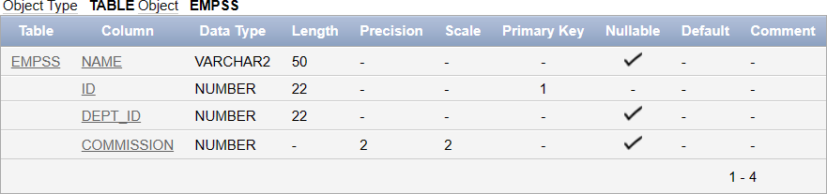

ALTER TABLE EMP ADD CONSTRAINT chk_commission_positive CHECK (COMMISSION > 0);

